Author: David Barlex and Torben Steeg

Published: 31/08/2022
Final Version

D&T Pedagogy
Re-building D&T: Good practice
How best we might teach design & technology to achieve the breadth of learning that is required?
The following sentences, derived from the writings of Jacob Bronowski in his seminal work, The Ascent of Man (1973), provide a powerful justification for teaching the subject that touches on all four of the arguments noted in the previous section (economic, personal, social, cultural).
Envisaging what might exist in the future and using tools and materials to create and critique that future is a unique human ability, which has led to the development of successive civilisations across history. It embodies some of the best of what it means to be human.
Through teaching young people design & technology schools introduce pupils to this field of human endeavour and empower them to become people who see the world as a place of opportunity where they and others can, through their own thoughts and actions, improve their situation.
The underlined words and phrases in the justification have considerable implications for the subject as shown in the table below.

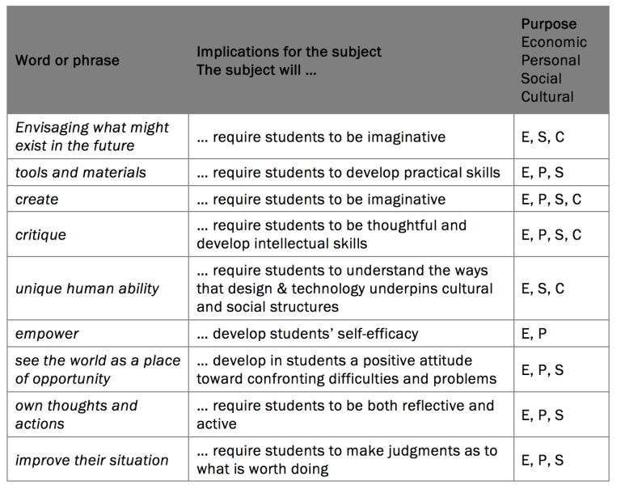

These implications, in turn, inform the activities that can be used to build an appropriate set of pedagogies for the subject.
Four broad activities are generally recognised as being required to make up an appropriate pedagogy:
- designing and making
- making without designing
- designing without making
- considering consequences.
Designing and making
This is often seen as the heartland of design & technology education, although it does not reflect the reality of technological activity in the world outside school, where those who design artefacts are usually not those who manufacture them.
The decision making that pupils need to undertake when they are designing and making has been described as involving five key areas of interdependent design decision (Barlex, 2007), shown diagrammatically in Figure 2:
conceptual (overall purpose of the design, the sort of product that it will be),
technical (how the design will work),
aesthetic (what the design will look like),
constructional (how the design will be put together),
marketing (who the design is for, where it will be used, how it will be sold).
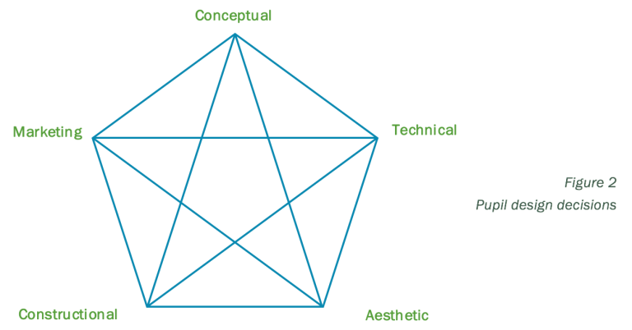
The interdependence of these areas is an important feature of making design decisions, as change of decision within one area will affect some if not all of design decisions that are made within the others. It is the juggling of these various decisions to arrive at a coherent design proposal that can then be realised to the point of fully working prototype that provides the act of designing and making with intellectual rigour and educational worth and makes it an essential part of technology education.
The Nuffield Design & Technology Project coined the term “capability task” for designing and making assignments as it was through attempting such tasks that young people would develop and reveal their technological capability. The Project was very clear as to the need for this activity to be underpinned by two broad areas of knowledge: knowledge of the problem and knowledge for the solution.

Knowledge of the problem
Knowledge of the problem is always specific to the problem being addressed and needs to be found by exploring the situation in which the problem is embedded. It cannot be “looked up” in a general design & technology reference text. Because the scope of this knowledge can’t be predicted (and thus taught) in advance of exploring the design context, some have described the acquisition of this kind of knowledge “Just-in-Time” learning” (Gershenfeld, 2005).

A good example of the power of “Just-in-Time” learning arises when pupils are engaged with a designing and making task for young children. They realise that to understand the specific needs and wants of the children they are designing for they need to know more about, for example, the particular reading abilities of these children which might be different to their age expected reading ability. Pupils can be taught general strategies for observing situations and identifying the needs and wants of people in those situations. But the pupils have to build on those strategies for themselves when learning about pertinent aspects of a particular context – just in time to help them understand the nature of the design decisions they will need to make. And, of course, this is an iterative process, with pupils revisiting the situation as they use strategies to find out more about the requirements their design proposals must meet.
Knowledge for the solution
Knowledge for the solution can be more easily recognised and acquired than knowledge of the problem in that, for any domain of design & technology, the knowledge does not change as the design task changes. Gears, for example, behave in the same way, in terms of principles, whether they are used in a child’s toy, a lawn mower or a motor car, although the detailed arrangement and robustness of the gearing system developed to operate in these artefacts will be different.
To ensure that students had the practical and intellectual resources with which to be capable, the Nuffield Project devised a wide range of “Resource Tasks” which could be used to teach (a) design strategies, (b) technical knowledge and understanding, and (c) making skills. It is the learning through Resource Tasks that enables young people to make sound design decisions. One might describe some Resource Task learning as “Just-in-Case” learning; learning that is likely, but not inevitably, to be useful in the future. A pupil might choose not to use what they have learned about, for example mechanisms, by avoiding mechanical solutions altogether. However, one important aspect of Just in Case learning relating to knowledge for the solution is that it can enable Just-in-Time learning. If a pupil knows nothing or very little about a particular area of knowledge and realises that some knowledge about this might be useful for a solution to a design problem then it is a very steep just-in-time learning curve. If, however, the pupil knows something about the area, through some just-in-case learning, extending this knowledge just-in-time becomes much more feasible. Ian Leslie’s main argument in Curious (2014) is particularly pertinent: the more you already know the easier it will be to find out about what you don’t know and need to know. The Resources Tasks are also designed to support individual Just-in-Time learning; an individual can use appropriate tasks to develop knowledge as it is required.
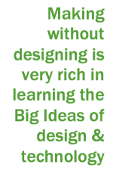
Making without designing
Making without designing also has a place in the pedagogy. Imagine an activity in which Year 7 pupils make (and then fly) a kite. The teacher has provided the plans for the kite and, if followed faithfully, they are known to produce a kite that flies well. What might a pupil learn from making a simple kite? They would certainly learn making skills involving textiles and resistant materials. Given the nature of kites there is the possibility of teaching about forces in structures as well as key aspects of health and safety e.g. not flying near electricity pylons, avoiding cuts from taut string and preventing being pulled over.
If pupils are given a choice of materials, there is the possibility of carrying out investigations into their properties and using the results to decide on which materials to use – both for the fabric and the frame.
So, this making without designing activity is very rich in learning Big Ideas (conceptual knowledge) of design & technology. Additionally, acquiring making skills is almost certainly highly enjoyable for the pupils.
Designing without making
Designing without making is an approach developed extensively by the Young Foresight project as the means to improve the ability to communicate design ideas, cultivate creativity and enable collaboration in design & technology lessons. Independent evaluations (Murphy, 2013) of designing without making have shown that young people do not necessarily require “something to take home”. Pupils respond enthusiastically to working collaboratively to develop design ideas providing they know at the outset that that they would not be going to make their designs. In fact, this “not requiring to make’” was welcomed by the pupils, as it released them from the constraints of the materials and equipment available in their school workshops.
An important feature of this approach is that pupils themselves decide on the need or want they will address and make conceptual design decisions accordingly, which provides ownership and motivation. The pupils do, however, have to justify their ideas in terms of feasibility, meeting needs and wants, acceptability to society and marketability.
Considering consequences
The opportunity for pupils to consider the consequences of a technology and its impact on society in general and their lives in particular is an important element of design & technology. Critique is one of the Big Ideas that underpin the subject. It is through learning to critique that young people will be enabled to partake in and contribute to on-going debates about what we do with the technology at our disposal.
A simple “winners and losers” analysis, to identify the impact of a product or technology on those who it might affect, is a very powerful way of engaging young people in considering consequences. Identification of “winners and losers” features in both the Nuffield Design & Technology Project and Young Foresight.
We note that it is fairly straightforward to assess each of these four types of activity, providing the teacher is clear about the learning intentions underpinning the activity.
In summary, any “grand plan” for a design & technology curriculum will need to give each of these four activities appropriate significance. Depending on the age and stage of the pupils’ design & technology experience the relative significance of these components may vary within each year of the course. But there is a strong case that each should be present, to some degree, within each year.
While we have emphasised the learning value of these four approaches to teaching design & technology others have pointed to pupils’ huge enjoyment of the practical activity of making and suggested that it is this alone which earns the subject its place in the curriculum. While we agree that making is a very important aspect of the subject, we are adamant that if this is seen as the sole reason for its inclusion in the curriculum then the status of the subject will remain low. This is not to deny the power of making, particularly successful making, which can increase a person’s confidence and self-belief.
Achieving good practice
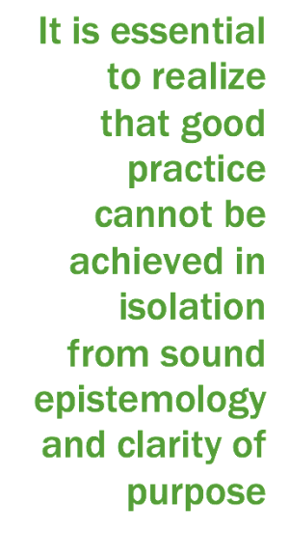
Teachers are introduced to the features of good practice in design & technology during their initial training but inevitably there is only a limited appreciation of what this entails. Once a teacher is in post, he or she develops further good practice through their day-to-day teaching and learning from colleagues. This is further enhanced through appropriate CPD. It is essential to realise, however, that good practice cannot be achieved in isolation from sound epistemology and clarity of purpose. Any department wishing to develop good practice must first establish agreed statements on (a) what it will be teaching in the subject and (b) why it is teaching the subject. Only once these are established can a department develop an appropriate pedagogy.

Hence any CPD that is provided by the Design & Technology Association or others whose aim is to achieve good practice will need to take all three features (how, what, and why) into account. Visually this can be represented as three vectors of ‘what’ ‘why’ and ‘how’ (Figure 3).

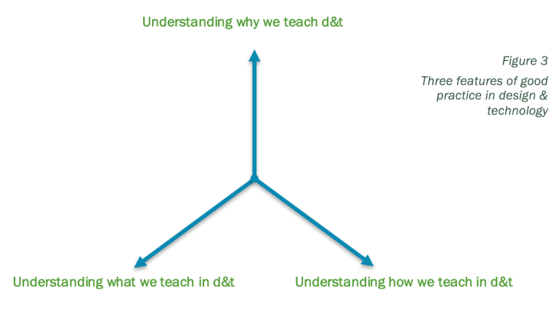
If we imagine a school department’s journey towards better and better practice, these three vectors of activity need to be considered together in the planning and provision of appropriate CPD. Movement along any one vector will be dependent on movement along the other two vectors.
Given the confusion surrounding the epistemology of the subject and the purposes for which it is taught, it is essential that as much as possible of the CPD provision available in the immediate future should consider each of these three features.
As an orthodoxy about subject knowledge is reached and the variety of reasons for teaching the subject become more widely understood, this constraint on CPD may be relaxed. This would allow more concentration on how we teach and a focus on those aspects of what we teach that are seen as necessary or relevant at the time. Developing Great Teaching (Teacher Development Trust, 2015) provides a useful summary of research into what constitutes effective professional development for teachers and the DfE has published Standard for teachers’ professional development (Department for Education, 2016) which reflects the research findings. Recent summaries of research into effective teaching practices include those from the Sutton Trust (Coe, Aloisi, Higgins and Major, 2014) and Hattie and Yates (2013); effective CPD will need to take these lessons into account. Two key points are that professional development programmes should be sustained over time and must be prioritised by school leadership.
The sort of professional development supported by research and envisaged by the Department for Education goes much further than providing a single day of advice about enhancing students’ public examination performance (important though this is). Hence it is vital that design & technology departments are supported in creating a sustained and substantial professional development programme. Such a programme should (a) support the individual needs of teachers within the department, (b) simultaneously develop good practice across the department and (c) contribute to the modernisation of the design & technology curriculum
It is here that we become torn between the ideal situation – regular, related CPD sessions over time with the opportunity to explore and evaluate the impact of changes in practice – and the pragmatic reality of what most schools can afford, both in terms of the time available for teacher release and the finances available for CPD. One strategy to overcome these difficulties is for schools to collaborate through common CPD days, as is done by some teaching school alliances and Multi Academy Trusts.
The Design & Technology Association has some key roles to play in promoting good CPD to Senior Leadership Teams and in providing CPD that meets the research and Department for Education criteria for effectiveness. A further important role for the Design & Technology Association will be in establishing non-governmental financial support to underwrite at least some of the costs of such high-quality CPD.
Much is made of the need for so-called “soft” skills (perhaps better called generic skills): problem solving, communication, team working. In our view, there is nothing ‘soft’ about these in the sense that they are difficult to learn and can only be taught through direct experience carefully orchestrated by the teacher. As they are rarely assessed through formal examinations leading to qualifications they are often neglected. It is worth asking to what extent these skills might be developed through the teaching methods described in this paper. The successful completion of a designing and making task will almost certainly require problem solving and if a young person tackles several such tasks in different contexts over a period of time then it is reasonable to assume that they will become better at problem solving – at least in the general domain of design & technology. Collaborative designing-without-making tasks will require young people to work in teams and communicate. Given repeated exposure to this approach it seems reasonable to assume that these skills will improve. But we must question the validity of these assumptions. Just because it seems reasonable or plausible that these soft skills will be developed does not necessarily mean it is so. Research aimed at probing whether these spins-offs do actually take place in the teaching of design & technology is required. If such spin-offs do occur, how can they be maximised without compromising the integrity of the subject?
Recommendations
That key stakeholders from the design and engineering industries and professions support the Design & Technology Association in promoting and providing CPD that meets the research criteria for effectiveness.
That key stakeholders from the design and engineering industries and professions work with the Design & Technology Association to establish financial support for effective CPD.
That key stakeholders in the d&t community, including those from the design and engineering industries and academia, work with the Design & Technology Association to establish funding for research in response to key questions concerning the effective teaching of design & technology and the benefits of such teaching.
For further reading around D&T and more from David and Torben, visit their website David and Torben for D&T | Engage with the work that David Barlex and Torben Steeg are doing in D&T (wordpress.com)

Design and Technology
sarah.pook2@hants.gov.uk
For further details on the full range of services available please contact us using the following email:
htlcdev@hants.gov.uk
Upcoming Courses
Keep up-to-date with our learning opportunities for each subject through our Upcoming Course pages linked below. To browse the full catalogue of learning offers, visit our new Learning Zone. Full details of how to access the site to make a booking are provided here.
- English
- Maths
- Science
- Geography
- RE
- History
- Leadership
- Computing
- Art
- D&T
- Assessment
- Support Staff
- SEN

